SE-331 PROJECT PROPOSAL REPORT
AI-Powered Riverbank Erosion Risk Prediction and Early Warning System for Bangladesh
Prototype using IoT sensing and Machine Learning
Course | SE-331
Program | B.Sc. in Software Engineering
Group name / number | Risk Prediction
Submission date | 5-10-26

Member | Name | Student ID
Member 1 | Dhroubo Jyoti Mondal | 232-35-182
Member 2 | Hasib – Ur - Rahman | 232-35-590
Member 3 | Masud Ibne Mostofa | 232-35-553

1. Introduction

1.1 Background Overview
Application domain. Environmental monitoring and disaster early warning. Bangladesh is a delta country where large rivers such as the Jamuna, Padma and Meghna constantly shift their banks. Riverbank erosion destroys farmland, homes, roads and embankments, and every year it displaces families who often have little time to move belongings or livestock.
Current practices. Monitoring today relies mainly on: (a) river water-level gauge stations, (b) manual field inspection and local observation, (c) historical erosion records and maps, and (d) satellite imagery and GIS analysis. These give valuable regional information, but they report what the river is doing or has already done. None of them gives a small community a localized, automatic, forward-looking signal.
Use of AI in this domain. Machine Learning is already used in flood forecasting, hydrology and remote-sensing studies. These systems usually depend on large datasets, specialized infrastructure or large-scale deployment, and they are rarely available at the level of a single vulnerable village bank. Low-cost, locally deployed AI for erosion risk is largely absent.

1.2 Problem Statement
Riverbank erosion is caused by a combination of factors: water level and its rate of change, rainfall, soil moisture and bank instability. Today, assessing the danger at a specific bank depends on people visiting and judging it by eye. This has four limitations:
- Continuous watching of every vulnerable location is not possible by manual observation.
- Reading several indicators together and judging how they combine is subjective and depends on individual experience.
- Existing systems mostly describe the present situation and do not estimate the chance of erosion in the coming hours.
- Warnings reach communities late, or not at all.
Who is affected: families, farmers and landowners living near eroding banks, and the local authorities responsible for them. Why software is needed: measurements must be collected continuously, stored, processed and shown to non-experts in a simple form, which is not practical on paper. Why AI is needed: today a human expert manually compares current water level, rainfall and bank condition against what they remember from past erosion events. The AI replaces this manual judgment by learning the relationship between those indicators and past erosion events from data, then applying it automatically to every new reading to give a probability of erosion within a future time window.
The project is scoped as a student prototype that predicts risk, not exact erosion location or land loss, and it makes no accuracy claims before real evaluation.

1.3 Objectives
General Objective: To develop a low-cost IoT and AI-based prototype that continuously monitors riverbank conditions and warns of rising erosion risk through a web dashboard and a local alert unit.
AI Objective: To train and evaluate a supervised Machine Learning model that takes environmental and bank-condition features as input and outputs the probability of erosion risk within a future time window, and to compare candidate algorithms to select the most suitable one.

1.4 Scope
In-scope | Out-of-scope
ESP32-based collection of water level, rainfall, soil moisture, bank tilt/movement, vibration, temperature and humidity (where feasible) | Deployment along an entire river or multiple sites; the prototype targets one monitoring station or a model setup
Wireless transmission to a server and database storage | Building bank-protection structures or controlling river flow
Historical data integration, preprocessing and feature engineering | Predicting the exact erosion location or amount of land loss
ML-based erosion-risk prediction and Low/Medium/High/Critical classification | Replacing official disaster-management or hydrological authorities
Web dashboard with live readings, trends and risk level | Geological surveys, permanent commercial deployment, mobile app and SMS
Local warning using LEDs and a buzzer | Deep learning on satellite imagery
Model comparison, evaluation and feature-importance analysis | -

The AI will | The AI will not
Learn patterns from historical and sensor data; output an erosion probability and risk level for a future time window; show which inputs mattered most; support early-warning decisions | Guarantee that erosion will or will not happen; stop erosion automatically; replace expert hydrological or geological assessment; claim accuracy beyond what is measured on test data

Boundaries: one prototype station, a fixed set of sensors, decision support only. Any new sensor or feature outside this list is treated as future work.

1.5 Stakeholders
Stakeholder | Role | Interest in the system
Riverbank residents, farmers and landowners | End users | Receive early warning to move people, livestock and crops in time
Local authorities | Client / decision makers | Use risk information for local planning and response
Disaster-management and water-resource organizations | Potential clients / regulatory bodies | Use the output only as supplementary information; the system must not conflict with official guidance
System administrator | Operator | Maintains devices, server, database and model
Student team and course instructor | Developers / evaluators | Design, build and assess the prototype

1.6 Proposed Solution
The solution is an end-to-end pipeline. An ESP32 node reads the sensors every few minutes and sends the data over Wi-Fi to a backend API, which stores it in a database. A preprocessing step cleans the data and builds features such as water-level change and accumulated rainfall. The trained ML model converts these features into an erosion probability, which is mapped to a risk level. The level is shown on the dashboard and sent back to the ESP32 to drive LEDs and a buzzer. To avoid false alarms from a single noisy reading, a warning is raised only when high risk persists over several consecutive predictions.
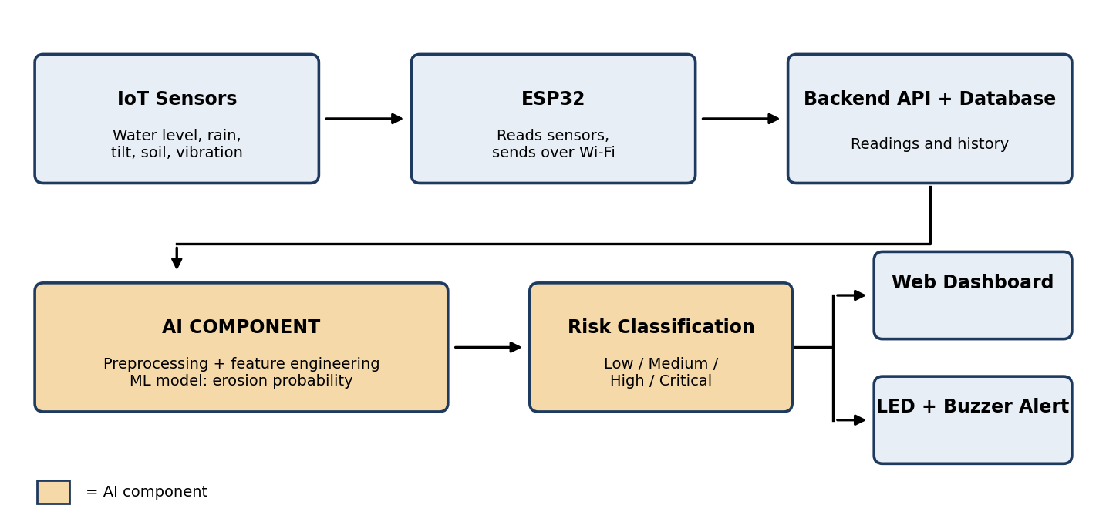
Figure 1. System overview. Shaded boxes mark the AI component.

1.7 AI Features

Existing AI features and limitations
- Flood and water-level forecasting models: predict river level, not bank erosion, and run at regional scale.
- Satellite/remote-sensing erosion analysis: shows past bank-line changes with delays of days or weeks, and cannot warn within hours.
- Large hydrological models: need big datasets and specialist expertise, and are not available for a single village bank.

Proposed AI features
Feature | Input | Output | Manual work it replaces
F1. Erosion-risk prediction | Water level and its change, accumulated rainfall, soil moisture, bank tilt, vibration, temperature, humidity | Erosion probability for the next time window | An expert mentally combining many indicators to judge danger
F2. Risk classification | Predicted probability plus recent predictions | Low / Medium / High / Critical | Deciding by eye when a situation is serious enough to warn
F3. Feature-importance analysis | Trained model and test data | Ranked list of influential factors | Guessing which factors drive erosion at this site

AI techniques
Supervised Machine Learning on structured, time-based data. Candidate models are Logistic Regression (baseline), Random Forest, XGBoost and Support Vector Machine, compared on a time-ordered test set. Feature importance uses Random Forest/XGBoost importance and optionally SHAP. Deep models such as LSTM are not planned unless enough sequential data is collected.

Why AI is essential
If the AI is removed, the system can only display raw sensor values and fixed alarm thresholds. It can no longer do its main job: converting many changing measurements into a forward-looking erosion probability learned from past events. The prediction, classification and explanation features are all produced by the ML model, so the AI is the core of the product and not an add-on.

2. System Requirements

2.1 Functional Requirements
ID | Requirement
FR-01 | The system shall read water level, rainfall, soil moisture, bank tilt, vibration, temperature and humidity through an ESP32.
FR-02 | The system shall send each reading to the server over Wi-Fi with a timestamp and station ID.
FR-03 | The system shall store all readings and historical data in a database.
FR-04 | The system shall detect missing or invalid readings and handle them without crashing.
FR-05 | The system shall compute derived features, including water-level change and accumulated rainfall.
FR-06 | The system shall show live readings and historical trend graphs on a web dashboard.
FR-07 | The system shall show the device/communication status, including the time of the last received reading.
FR-08 | The system shall activate an LED and buzzer when the risk level is High or Critical.
FR-09 | The system shall require login for dashboard access and an API key for sensor data submission.

2.2 AI Requirements
ID | Requirement
AI-01 | The system shall train the model on historical labeled data and be retrainable on new data.
AI-02 | The system shall use a chronological train/test split to prevent future-data leakage.
AI-03 | The system shall produce an erosion probability (0 to 100%) for each new observation, with its prediction time window.
AI-04 | The system shall map the probability to Low, Medium, High or Critical using thresholds chosen on validation data.
AI-05 | The system shall raise a warning only when high risk persists across a set number of consecutive predictions.
AI-06 | The team shall evaluate at least three algorithms using Accuracy, Precision, Recall, F1-score and ROC-AUC, and report the results on the test set.
AI-07 | The system shall display the most influential input features for the trained model.
AI-08 | The dashboard shall present predictions as risk estimates with a note that they are not guaranteed.

2.3 Non-Functional Requirements
- Performance: a new reading shall appear on the dashboard together with its prediction within one minute under normal network conditions.
- Reliability: the system shall keep running and show a status warning when a sensor or the network fails.
- Usability: a non-expert shall be able to read the current risk level from the dashboard home page.
- Maintainability: IoT, backend, database, ML and dashboard modules shall be separate.
- Scalability: the data model shall support adding more stations later.

3. Tools and Technologies
Category | Technologies
Hardware | ESP32; JSN-SR04T waterproof ultrasonic sensor (water level); MPU6050 (bank tilt/vibration); soil-moisture sensor; DHT22 (temperature/humidity); rain sensor or tipping-bucket gauge; LEDs, buzzer; power bank; enclosure
Programming languages | Python, C/C++ (Arduino framework), JavaScript, SQL, HTML/CSS
AI / data libraries | Pandas, NumPy, Scikit-learn, XGBoost, Matplotlib, SHAP (optional); Google Colab / Jupyter
AI models | Logistic Regression, Random Forest, XGBoost, SVM (own models trained on project data; no external LLM API)
Backend | FastAPI or Flask (REST API); model served as a saved file loaded by the backend
Database | PostgreSQL or MySQL
Frontend | HTML, CSS, JavaScript, Chart.js; Leaflet/OpenStreetMap for the station map
Development tools | Arduino IDE or PlatformIO, VS Code, Git/GitHub

4. Project Timeline and Work Plan
The project runs for 6 weeks. Team size is 4; replace member names as needed.
Week | Milestone | Main tasks | Deliverable | Owner
1 | M1: Planning | Requirements, literature and data-source study, define labels and prediction window | Requirement and data plan | All
2 | M2: Data and IoT | Collect/clean historical data; assemble ESP32 and sensors; test readings | Initial dataset, IoT prototype | Member 1, Member 2
3 | M3: Backend | Database schema, REST API, feature engineering | Working backend, processed dataset | Member 3, Member 2
4 | M4: ML model | Train and compare models; time-based evaluation; feature importance | Trained model and evaluation results | Member 2
5 | M5: Integration | Dashboard; connect ESP32, backend and model; alert unit | Integrated system | Member 4, Member 1, Member 3
6 | M6: Testing and finalization | System and model testing, bug fixes, report, demo | Final prototype, report, presentation | All

Member | Responsibility
Member 1 | IoT hardware, ESP32 firmware, sensor integration, local alert unit
Member 2 | Dataset, preprocessing, feature engineering, ML training and evaluation
Member 3 | Backend, database, API, security, model serving
Member 4 | Web dashboard, testing, documentation, presentation

5. Optional Sections

5.1 Existing System
River-level gauge stations, field inspection, historical records and satellite/GIS analysis are the current tools. They are important but regional, manual or delayed. This project adds a localized, automatic and predictive layer and does not replace them.

5.2 System Architecture
The architecture is layered: (1) sensing layer (sensors + ESP32), (2) communication layer (Wi-Fi, REST API), (3) data layer (database), (4) intelligence layer (preprocessing, ML model, risk classification), and (5) presentation layer (dashboard and LED/buzzer alert). Figure 1 shows the data flow.

5.3 Ethical, Legal and Social Considerations
- Risk of false alarms and missed warnings: both are costly. Thresholds will be tuned with this trade-off in mind and results reported honestly.
- No overclaiming: predictions are shown as probabilities and the system is labelled as a prototype and decision aid.
- Data privacy: no personal data is collected; only environmental and location-of-station data are stored.
- Data bias: a model trained on limited data from one river may not hold elsewhere; this limitation is stated.
- Environmental impact: sensors should be small and removable and cause no damage to the bank.
- Official guidance: users are told to follow official authorities in an emergency.

5.4 Future Work
- Multiple stations and LoRa/LoRaWAN long-range communication
- Better flow-velocity and rainfall sensors
- Satellite-image-based erosion detection and GIS mapping
- Deep learning when enough time-series data exists
- Mobile app and SMS alerts; integration with official platforms
- Field validation across different rivers and river-specific models

Risks and Assumptions
Labeled data is the main risk. A supervised model needs examples of past erosion and non-erosion periods linked to environmental conditions. The team will first confirm what labeled historical data can be obtained (for example public hydrological records and erosion reports). If real labels are limited, the prototype will be evaluated on the available data and any simulated or proxy data will be clearly marked as such. No accuracy figures are claimed in this proposal; they will be reported only after training and testing.

